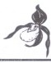
J. Eur. Orch.
44 (2): 403 - 412. 2012.
Leslie Lewis & C.A.J. Kreutz

Ophrys apifera Huds. var. badensis var. nov.

Keywords

Orchidaceae, Ophrys apifera var. badensis, Ophrys apifera var. botteronii, Ophrys apifera var.friburgensis, Ophrys apifera subsp.jurana.

Summary
Lewis, L. & C.A.J. Kreutz (2012): Ophrys apifera Huds. var. badensis var. nov.- J. Eur. Orch. 44 (2): 403-412.
The form of Ophrys apifera with sepaloid petals and a globular lip with a
horseshoe-shaped pattern like Ophrys apifera var. apifera ("typical lip") is named Ophrys apifera Huds. var. badensis L. Lewis & Kreutz. Previously, this form has generally been called Ophrys apifera var. friburgensis. However, as explained by BAUMANN (2005: 545), this name is incorrect since, as described by FREYHOLD (I 879: 220), the lip of Ophrys apifera var.friburgensis is almost flat and coloured yellow with darker, velvety brown patches. Since the well known Ophrys apifera var. botteronii (Ophrys botteronii CHODAT 1889: 188) is also represented by this description, it is a synonym of Ophrys apifera var. friburgensis which has priority. Because of this, Ophrys apifera var. botteronii was replaced by Ophrys apifera var. friburgensis in BAUMANN, KONK.ELE & LoRENZ (2004: 778). In addition, Ophrys apifera var. friburgensis was replaced by Ophrys apifera var. jurana for the form with sepaloid petals and a typical lip. However this name, listed by BAUMANN (2005: 545) as Ophrys apifera Huds. var.jurana (Neuberger) J. Schuster, was not validly published.

Zusammenfassung
Lewis, L. & C.A.J. Kreutz (2012): Ophrys apifera Huds. var. badensis var. nov..- J. Eur. Orch. 44 (2): 403-412.
Die Form von Ophrys apifera mit sepaloiden Petalen und konvexer
gelblichgruner und tleckenformiger Lippe, die jener der Nominatsippe gleicht (typische Malgestaltung), wird in diesem Beitrag als Ophrys apifera Huds. var.
Journal EuropaischerOrchideen 44 (2): 2012. 403

badensis L. Lewis & Kreutz ncu beschrieben. Friiher war diese Form als Ophrys apifera var. friburgensis FREYHOLD (1879: 220) bekannt. Jedoch hat BAUMANN(2005: 545) festgestellt, dass Ophrys apifera var. friburgensis und Ophrys apifera var. botteronii (Ophrys botteronii CHODAT I889: I88) das gleiche Taxon darstellen. Die Beschreibung dieses Taxons zeigt aber, dass die Lippe hellgelb ist und dunkler, samtbraun Flecken tragt, womit die bislang bezeichnete Ophrys apifera var. botteronii gemeint ist.
Da Ophrys apifera var. friburgensis mit Ophrys apifera var. botteronii iibereinstimmt und prioritatsberechtigt ist, tritt fur das friiher als Ophrys apifera var. friburgensis bezeichnete Taxon Ophrys apifera var. jurana ein (BAUMANN, KONKELE & LORENZ 2004: 778), wobei Ophrys apifera var. botterronii <lurch Ophrys apifera var. friburgensis ersetzt wird. Jedoch wurde dieser Namen, der von BAUMANN (2005: 545) als Ophrys apifera Huds. var. jurana (Neuberger) J. Schuster bezeichnet wurde, nicbt giiltig veroffentlicht.

* * *

Background

Ophrys apifera Huds. is the most widespread Ophrys species in Europe and adjacent countries. In its nominative form ("var. apifera") (Fig. 3), the lip ("typical lip") is convexly globular and tri-lobed in shape with a yellow appendage at its tip; the colour is dark or reddish-brown marked with a pattern in the form of a narrow horseshoe-shaped speculum surrounded by a yellow or yellowish-white border with two yellowish spots or streaks below. The sepals are ovate to linear ovate, pink marked with green veins. The petals are small, triangular or oblong in shape, green or pink in colour.

0. apifera is normally self-pollinating and a number of variants have been recorded, and formally named. These variants include one with "sepaloid" petals, that is large, linear-ovate petals which are shaped and coloured like the sepals, although rather smaller (typically ²/3 as long and ¹/2 as wide). This variant was first recorded in Germany as Ophrys apifera var. friburgensis by FREYHOLD ( 1879: 220) and from Switzerland as Ophrys botteroni(i) by CHODAT ( I889: 188) (syn. Ophrys apifera var. botteronii (Chodat) Brand). However, it has also been recorded from France, see, for example DELFORGE (2006: 448) and BOURNERIAS (2005: 399). For Britain, see, for example (MACKIE et al. 2011: 80-82) and there would seem little doubt that it occurs elsewhere within the extensive range of Ophrys apifera.

404 Journal Europiiischcr Orchidecn 44 (2):2011

Ophrys apifera specimens with sepaloid petals often possess a typical lip similar to that of Ophrys apifera var. apifera. However, some specimens have a flatter lip with an abnormal pattern; in addition, the appendage is vestigial or missing. The epithets friburgensis, botteroni(i), jurana and saraepontana have been variously applied to these different forms at ranks ranging from species to forma.

In particular, the name Ophrys apifera subsp. jurana is used for all forms of Ophrys apifera with sepaloid petals, irrespective of the lip shape and pattern. At a lower rank, Ophrys apifera var. friburgensis has been widely used to denote the form with a typical lip, while Ophrys apifera var. botteronii has been used for a form with an almost flat lip and a yellow lip with brown patches instead of the typical Ophrys apifera pattern.

This use of the epithets jurana,friburgensis and botteronii can be attributed to ZIMMERMANN ( 1911: 2) who described and illustrated the following taxa:

"Ophrys apifera Huds. subsp. jurana [Ruppert]: lnnere Perigonblatter flach und blumenblattartig verbreitert, den iiusseren an Gestalt und rosaroter Fiirbung iihnlich, doch nur ²/3 so fang als sie.
var. a.friburgensis: Jnnere Perigonblatter papillos behaart bei typischer oder etwas weniger konvexer Lippe und vorhandenem wenn auch kleinem, griinem Anhangsel. Jurazug bis Freiburg i. Br.
var. b. botteroni Chodat: lnnere Perigonblatter vollig kahl, Lippe fast flach. Zeichnung meist stark vom Typus abweichend. Fehlen eines grunen Anhangsels, statt <lessen kurzer, braungruner Lappen."

A form described as intermediate between these two vaneties was subsequently named Ophrys saraepontana by RUPPERT {1924: 181). This was later reduced to the rank of variety by SO6 (in KELLER et al. 193 l: 69, nom. illeg.) and by BAUMGARTNER & KREUTZ (in KREUTZ 2010: 215).

The nomenclature of the two varieties listed by ZIMMERMANN ( 1911: 2) was based on the incorrect assumption that Ophrys apifera var. friburgensis Freyhold_had a typical lip; (Zimmermann states that he had not read Freyhold's paper). In fact, as explained by BAUMANN (2005: 545-546), Ophrys apifera var.friburgensis was described by FREYHOLD (1879: 220) as follows:

"Meine neue Ophrys apifera var. Friburgensis Frid. zeigt grosse, den Sepalen vollig in Gestalt, Farbe und Mangel der Behaarung gleichende und in den Dimensionen ihnen nur wenig nachstehende seitliche Petala. Die Lippe ist bei frischen, unverwelkten Bliithen schwach convex, mit kaum entwickeltem
Journal Europllischcr Orchidecn 44 (2): 2012. 405

Anhiingsel; nur die beiden oberen Seitentheile der Lippe sind <lurch geringe
Einschnitte etwas getrennt von dem ungetheilten, dreiwinkligen Mittelstiick,
<lessen Seiten von einer Spitze zur anderen sanft bogenformig concav verlaufen.
Ophrys apifera var. friburgensis Frid. = 0. apifera petalis duobus lateralibus sepala fcre acquantibus, rosaceis, glabris, planis, basi nullibi convolutis, - labello fere piano, paullum convcxo subdiviso vet subtrilobo, !obis labelli duobus lateralibus parvulis, lobo medio triangulato, apcndicc nullo vet angulos latcralcs Jobi medii piano acquante."

Thus, Ophrys apifera var. friburgensis Freyhold does not have a typical lip as bad been generally assumed following ZIMMERMANN (1911: 2). Instead, its lip is almost flat although weakly convex with gently curvl!d concave sides: and, instead of a typical pattern, it is coloured yellow with darker, velvety brown patches (Fig. 4). Because of this, Ophrys apifera var. botteronii was replaced by Ophrys apifera var. friburgensis in the "Taxonomische Liste der Orchideen Deutsch/ands" {BAUMANN, KONKLE & LORENZ 2004: 778) and "Die Orchideen Deutsch/ands" BAUMANN (2005: 544-545).

Having explained that the epithet friburgensis did not apply to the form with sepaloid petals and a typical lip, BAUMANN (2005: 545) listed that form under the name Ophrys apifera Huds. var. jurana (Neuberger) J. Schust. citing SCHUSTER {I 935: 435) and NEUBERGER {I925: 57). NEUBERGER (I.e.) included
Ophrys jurana in a list of Ophrys from Baden. This species was described as follows:
"Seitliche innerc Perigonblatter den liul3cren gleich oder lihnlich, rosa, flach. Anhlingsel vorgestreckt oder fehlend. 15-40 cm.
Jura- R.[= Jura Ragwurz), O.jurana W. Zimm."

Accordingly, like Ophrys apifera subsp. jurana Ruppert, Ophrys jurana
Neuberger is not restricted to the form with sepaloid petals and a typical lip.

The reference in the above name to "J. Schust." [= Julius Schuster (1886- 1949)) is in error" since the author was in fact Curt Schuster (1860-1935). More importantly, [C.] SCHUSTER (1935: 435) listed the two varieties:
0. apifera Huds. var. jurana Botteronii Chod. for the form with an abnormal lip citing ZIMMERMANN ( 1911: 2); and
(b) Ophrys apifera Huds. var. friburgensis Frey. for the form with a typical lip, again citing ZIMMERMANN (1911: 2).

Thus, although SCHUSTER published the epithet jurana in combination with

406 Journal Europaischcr Orchidccn 44 (2): 2012.

"Botteronit' for the form with sepaloid petals and an abnormal lip, he did not publish it for the form with sepaloid petals and a typical lip.
Accordingly, the name Ophrys apifera Huds. var. jurana (Neuberger) [C.] Schust. was not published for the form with sepaloid petals and a typical lip. In addition, since Ophrys apifera var. friburgensis Freyhold does not have a typical lip, the names including the epithetfriburgensis - for example, Ophrys apifera Huds. subsp. jurana Ruppert var. friburgensis (in ZrMMERMANN 19 I I: 2) and Ophrys apifera Huds. var.friburgensis (listed by SCHUSTER 1935: 435)
- are not valid names for the form with a typical lip.

Therefore, although generally named Ophrys apifera var.friburgensis, there is no existing legitimate name available at the rank of variety for the form of Ophrys apifera with sepaloid petals and a typical lip. With a view to rectifying this, Dr. K. Gandhi of the International Plant Names Index at Harvard University and Member of the Committee for Vascular Plants of the International Botanical Congress (pers. comm. 201I, 2012), Prof. W. Eccarius (pers. comm. 2011, 2012), and Dr. J.F. Veldkamp of Leiden University (pers. comm. 2011, 2012) were consulted as to the possibility ofretaining the epithet jurana for this form and of indicating the illustration in ZrMMERMANN ( 1911: 4, ill. b) as a lectotype. However, as result of these consultations - and as expressly advised by Dr. Gandhi - it was decided to publish a new trinomial with different epithet and to indicate a herbarium specimen as the type.

The reason for Dr Gandhi's advice is as follows. There is no existing legitimate name available at the rank of variety for the form of Ophrys apifera with sepaloid petals and a typical lip. Accordingly, as a new infraspecific taxon, the type for this new taxon must be a herbarium specimen under Art.

37.4 of the International Code of Nomenclature of algae, fungi, and plants
(ICN). Thus, although it would be possible to designate the illustration in ZIMMERMANN ( 1911: 4, ill. b) of Ophrys apifera with sepaloid petals and a typical lip as the lectotype of Ophrys apifera subsp. jurana, that illustration could not be indicated as type for the name of a new taxon.

In addition, although not an absolute requirement, it is apparent from Art. 26 of the ICN that, where a variety has the same final epithet as the species or subspecies which includes it, it is highly desirable that the variety should have the same type as that species or subspecies. Accordingly to retain the epithet jurana at the rank of variety for the form with sepaloid petals and a typical lip, a herbarium specimen of Ophrys apifera is needed which could be both (a) designated as lectotype for Ophrys jurana or Ophrys apifera subsp. jurana, and (b) indicated as holotype for the new taxon.
Journal EuropaischerOrchideen 44 (2): 2012. 407

Unfortunately, neither Ophrys jurana nor Ophrys apifera subsp. jurana was typified. ZIMMERMANN ( 1911: 3) refers various locations from which the form incorrectly named var.friburgensis Freyhold [= form with typical lip] had been recorded, including a 1907 record from Ebringer Kapelle, Schonberg. In view of this, consideration was given as to the possibility of designating specimens of Ophrys apifera from Schonberg on a sheet in Ttibingen Herbarium (TUB) as lectotype for Ophrys apifera subsp. jurana. This specimen sheet (Fig. I) consists of three flower spikes of Ophrys apifera collected by H.A. Krauss dated 02 June 1903 and four individual flowers dated 31 May 1925. Although the sepals and lips of the flowers on the three spikes cannot be clearly seen, it is apparent that the second individual flower from the top has a typical lip as well as sepaloid petals; also the text''friburgensis W.Z." (presumably= Walter Zimmermann) has been added to the sheet, consistent with Zimmermann's assumption that friburgensis had a typical lip. However, for the purposes of lectotypification of Ophrys apifera subsp. jurana only the specimens and text present on the herbarium sheet at the date of publication of that name (that is, 1911) can be used. Thus, the four individual flowers on the specimen sheet cannot be used to interpret the three flower spikes because they are dated 31 May 1925. The text ''friburgensis W.Z." also cannot be taken into account because it was almost certainly added after the publication of the name Ophrys apifera subsp. jurana. That leaves the three flower spikes dated 02 June I903. However, since the petals and lips of the flowers on these spikes cannot be clearly seen, in the opinion of the present authors it could not be shown in 19I I that these were specimens on which Zimmermann 's description validating the name Ophrys apifera subsp. jurana was based in accordance with Art. 9.2, Note 2(a)). Accordingly, the TUB specimen is not designated as a lectotype for the name Ophrys apifera subsp.jurana.
In the absence of a herbarium specimen of Ophrys apifera with sepaloid petals and a typical lip which could be both (a) designated as lectotype for Ophrys apifera subsp. jurana or Ophrys jurana, and (b) indicated as holotype for the new taxon, an epithet different from jurana was chosen for the new taxon in accordance with Dr Gandhi's express advice.

Although the four individual flowers dated 31 May 1925 and added text on the TUB specimen sheet could not be used for lectotypification of the earlier published name Ophrys apifera subsp. jurana, they are available for the typification of the name of a new taxon. In view of this, the gathering of the three spikes dated 02 June 1903 is indicated as the holotype in accordance with Art. 8.2 and 37.2 of the ICN. In addition, the second individual flower from the top, dated 31 May 1925, is cited as an epitype for the purpose of interpreting the holotype in accordance with Art. 9.7.

408 Journal EuropAischcr Orchideen 44(2): 2012.

Ophrys apifera Huds. var. badensis L. Lewis & Kreutz var. nov.

Diagnosis: Like Ophrys apifera Huds. var. apifera but petals large, linear ovate, shaped and coloured like the sepals although rather smaller (typically ²/
as long and 1/₂ as wide). Distinguished from both Ophrys apifera va
friburgensis and Ophrys apifera var. saraepontana by having a lip with shape and pattern like that of Ophrys apifera Huds. var. apifera.
Holotypus: Germany (Baden-Wiirttemberg): Freiburg im Breisgau Schonberg. Mountain meadow on southern slope, three flower spikes 02.06.1903, leg. I-I.A. Krauss (TUB), No. 019713 (Fig. I).
Epitype Germany (Baden-Wiirttemberg): Freiburg im Breisgau, Schonberg 31.05.1925, second individual flower from the top, left side on the herbariurr sheet (TUB), No. 019713 (Fig. I).
Etymology: From Baden, the name of the region on the east bank of the Rhim in the southwest of Germany, now the western part of Baden-Wiirttemberg This is the location of the type specimen and the best known region for thi form of Ophrys apifera.

Acknowledgements

We are greatly indebted to Prof. Wolfgang Eccarius, Dr. Kanchi Gandhi an Dr. Jan Frits Veldkamp for detailed discussions on how best validly to nam the above taxon under the ICN. We are also grateful to Ti.ibingen Herbariurr (Dr. Cornelia Dilger-Endrulat & Dr. M. Weil3) for providing a copy of the typ specimen and for permission to publish it. We are also grateful to Prof Wolfgang Eccarius for his critical appraisal of the manuscript.

Literature

BOURNERIAS, M. & D. PRAT (2005): Les Orchidees de France, Belgique e Luxembourg 2nd ed.- Paris.
BAUMANN, H. (2005): Ophrys apifera.- In: Arbeitskreise Heimische Orchidee (Eds.): Die Orchideen Deutschlands: 537-547.- Uhlstadt-Kirchhasel.
BAUMANN, H., KONKELE, S. & R. LORENZ (2004): Taxonomische Liste de
Orchideen Deutschlands. Nachtrag - J. Eur. Orch. 36 (3): 769-780.
CHODAT, R. (1889): Ophrys Botteroni Chodat.- Bull. Soc. Bot. Geneve 5: I87 190.
DELFORGE, P. (2006): Orchids of Europe, North Africa and the Middle East.
London.

Journal Europaischer Orchideen 44 (2): 2012.

FREYHOLD von, E. (1879): Kleinere botanische Mittheilungen Ober Orchideen.­ T,tgebl. Versamml. Deutscher Naturf. Artze 52: 220.
KELLER, G., SCHLECHTER, R. & R von S06 (1931): Monographie und lconographie der Orchideen Europas und des Mittelmeergebietes vol. 2.­ Feddes Repertorium, Sonderbeiheft A2, 2.-3. Lieferung: 41-120.- Berlin.
KREUTZ, C.A.J. (20 I0): Beitrag zur Kenntnis europliischer, mediterraner und vorderasiatischer Orchideen.- Ber. Arbeitskrs. Heim. Orchid. 27 (2): 171-
236.
MACKIE, S., MIELCAREK, R. & L. LEWIS. (2011): Ophrys apifera var. botteronii
in Britain.- Journal of the Hardy Orchid Society 8: 79-83.
NEUBERGER, J. ( 1925): Schulflora von Baden.- Freiberg im Breisgau.
RUPPERT, J. (1924): Orchideen-Kleinarbeit in der Saarbrticker Ecke.- Verb.
Naturhist. Ver. Preul3. Rhein!. Westf. 81: 180-183.
SCHUSTER, C. (I 935): Orchidacearum lconum Index. - Repert. Spec. Nov.
Regni Veg., Beih. 60: 435.
ZIMMERMANN, W. (191 I): Ophrys Botteroni Chodat in Baden.- Alig. Bot. Z.
17: 2-6.

Authors' addresses

Leslie Lewis
4 Orchid Meadow Chepstow NP16 6HP UK
Karel Kreutz,
Oude Landgraaf 35a, NL-6373 BE
Landgraaf.

410 Journal Europaischer Orchideen 44 (2): 20I2.


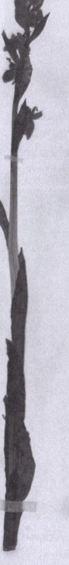

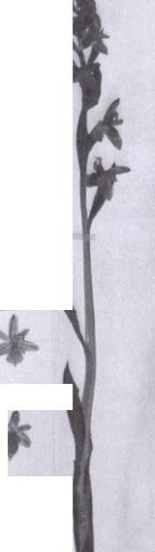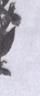01171:S
..."..

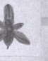
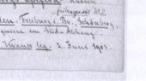
Fig. I: Herbarium specimen of Ophrys apifera Huds. var. badensis L. Lewis
& Kreutz var. nov. (TUB, No. 0 I 9713)
Journal Europllscbcr Orcludeffl 44 (2)• 2012. 411

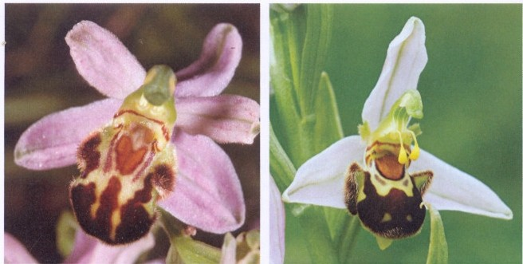

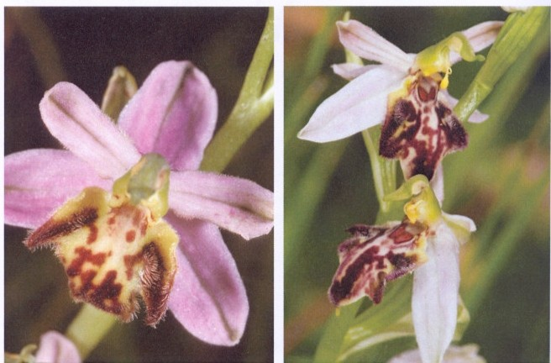
Fig. 2: Ophrys apifera var. badensis, Deutschland, Baden-Wurttemberg, Freiburg im Breisgau, Schonberg, 08.06.1980, phot. C.A.J. Kreutz.

Fig. 4: Ophrys apifera var.fribur­ gensis, Deutschland, Nordrhein­ Westfalen, Mechemich (Eifel), 16.06.2002, phot. C.A.J. Kreutz.

412
Fig. 3: Ophrys apifera var. apifera, England, Somerset, Weston-in Gordano, 11.06.2008, phot. L. Lewis.

Fig. 5: Ophrys apifera var. sarae­ pontana, Deutschland, Baden­ Wurttemberg, Goldschauer (Orten­ au), 13-06-2010, phot. C.A.J. Kreutz.

Journal Europdischer Orchideen 44(2): 2012.

